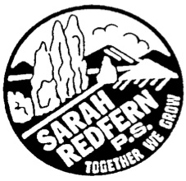 | Sarah Redfern Public School  Pathway to a successful future  5 Monaghan Street, Minto, NSW 2566  Phone: 9820-1499 Fax: 9820-2912  Email: sarahredfe-p.school@det.nsw.edu.au  www.sarahredfe-p.schools.nsw.edu.au

Friday 6th July, 2018

Public Speaking – Term 3

Dear Parents and Caregivers,

Next term all students K-6 are invited to join our school District Public Speaking Competition. There will be class competitions run first that will decide who will progress to the next level. We hope as many students as possible join in this competition.

There are no set topics for this competition, but topics must be appropriate to be discussed at school. It is very important that topics from the Multicultural Public Speaking Competition are not reused.

Timeline of Events
Week 6 | Students present their speeches to their teacher and class.  At the end of the Wk 7, each class will select one winner.
Week 7
Week 8 | SRPS Final in Hall - Friday September 14th where one winner will be selected to progress to the next level.
Week 9 | Network Final - Tuesday 18th September at Woodlands Public School

Speaking Times for each Age-Group

 | Length of  Prepared Speech | Bell times
Early Stage One (Kindergarten) | 1 minute | 2 bells will be rung at the completion time | 30 seconds after the completion time, the bell will be rung continuously
Stage 1 (Year 1 & 2) | 2 minutes
Stage 2 (Year 3 & 4 | 3 minutes
Stage 3 (Year 5 & 6 | 4 minutes

We look forward to hearing your opinions and being entertained.

Yours sincerely,

Mrs Tracey Quick Mrs Aimee Jahshan
Assistant Principal Relieving Principal

